**Add New Property to a Component and Display in drawing**

e.g. Introducing “RPM” for Component Type, Electric Motor.

I. **HyDraw Library Manager**

1. Open HyDraw Library Manager.
2. Select **Components** Menu.
3. Select **Model Properties** Menu.

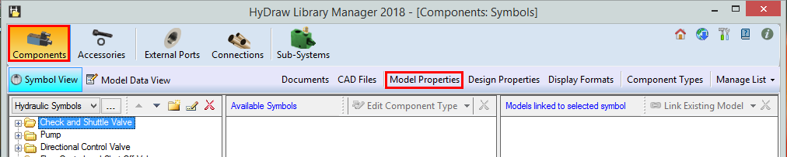

1. Click on **New** button.

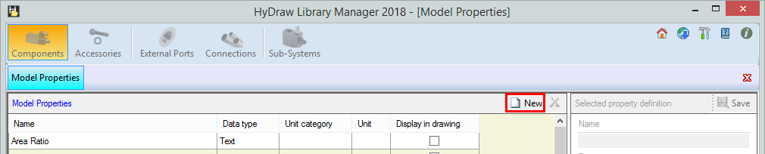

1. Define properties value as mentioned below: -

* Property name: RPM
* Data Type: Number
* Unit Category: Unitless

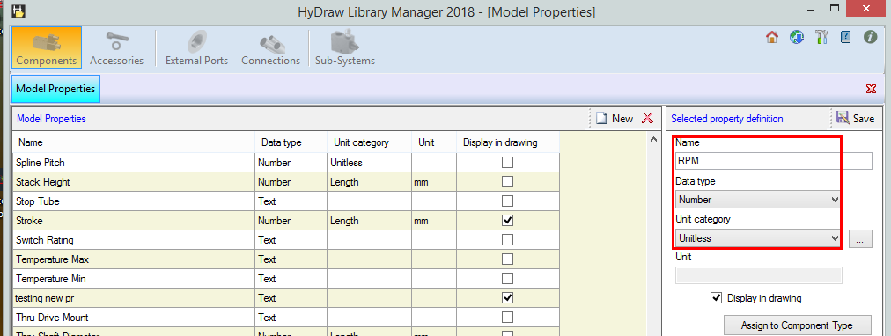

1. Select, **Display in drawing** option.

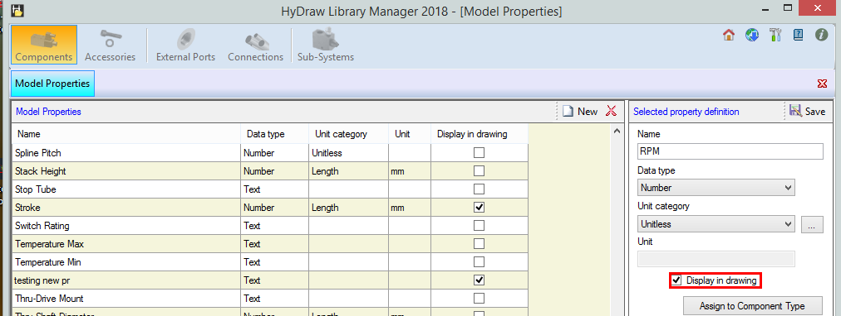

1. Click **Assign to Component Type** and then select the **Electric Motor** to assign.

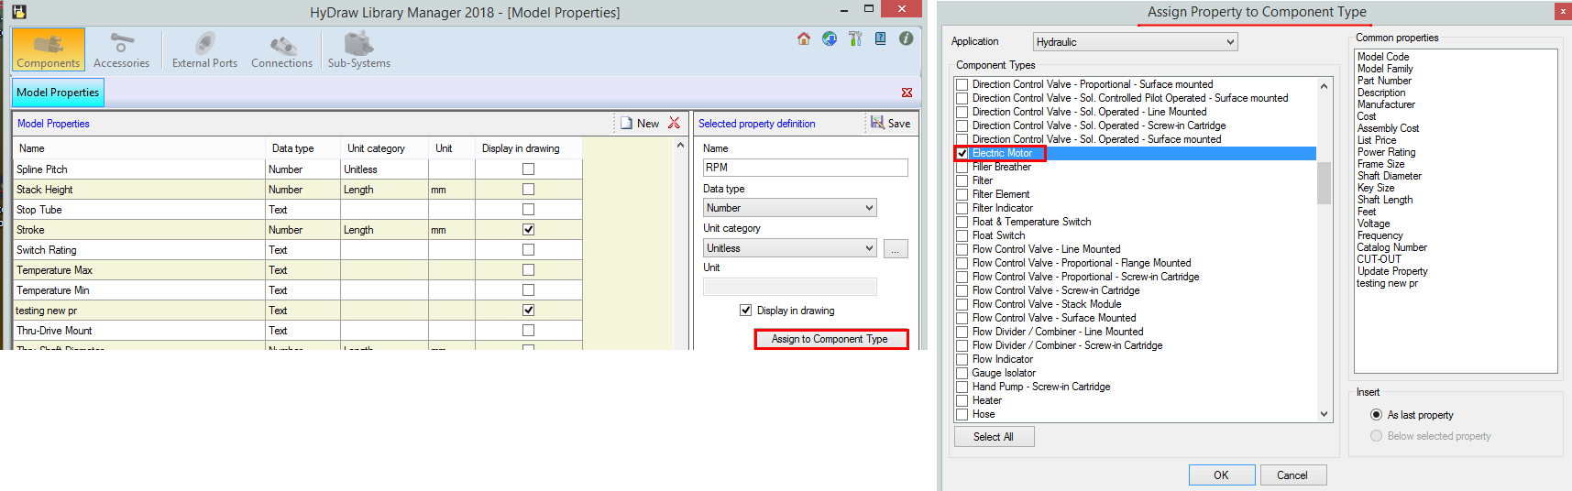

1. Click, **Save**.

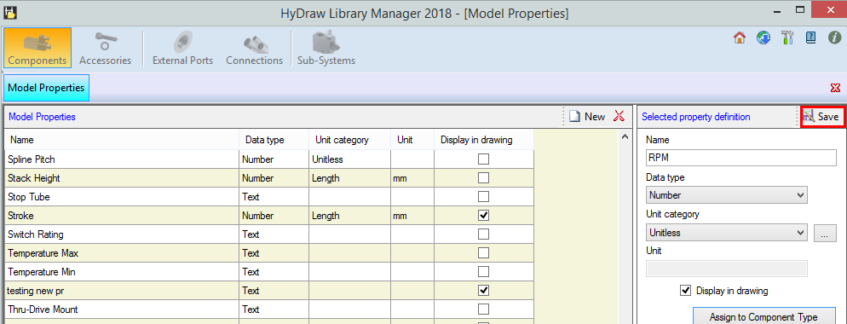

1. Click .

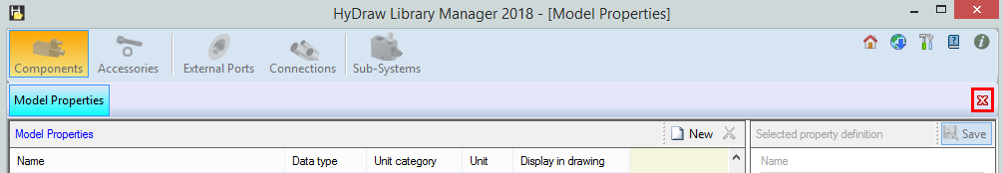

1. Select **Display Formats** menu.

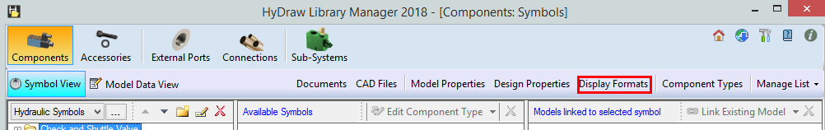

1. Click on **New** button.

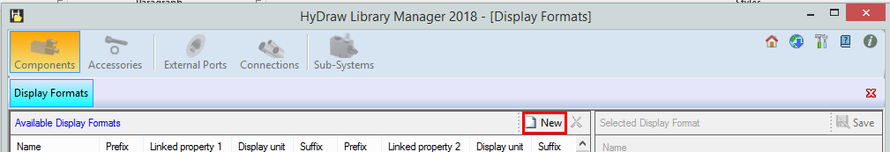

1. Enter **NAME,** RPM.

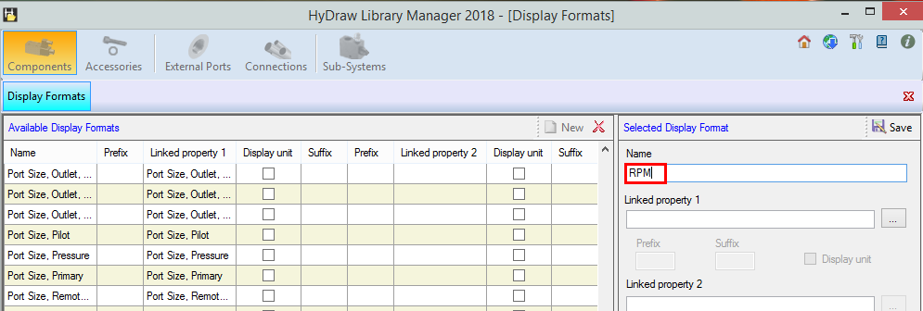

1. Select, Linked Property 1 as RPM. Click OK, click **Save**.

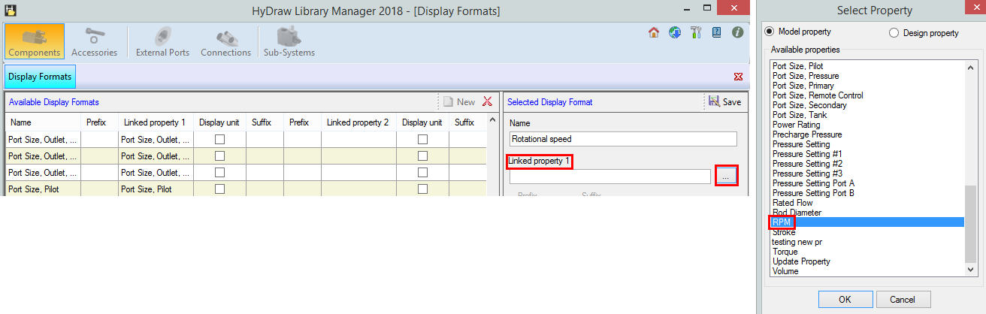

1. Select RPM from available display formats. Click **Assign to Component Type** and then select the **Electric Motor** to assign.

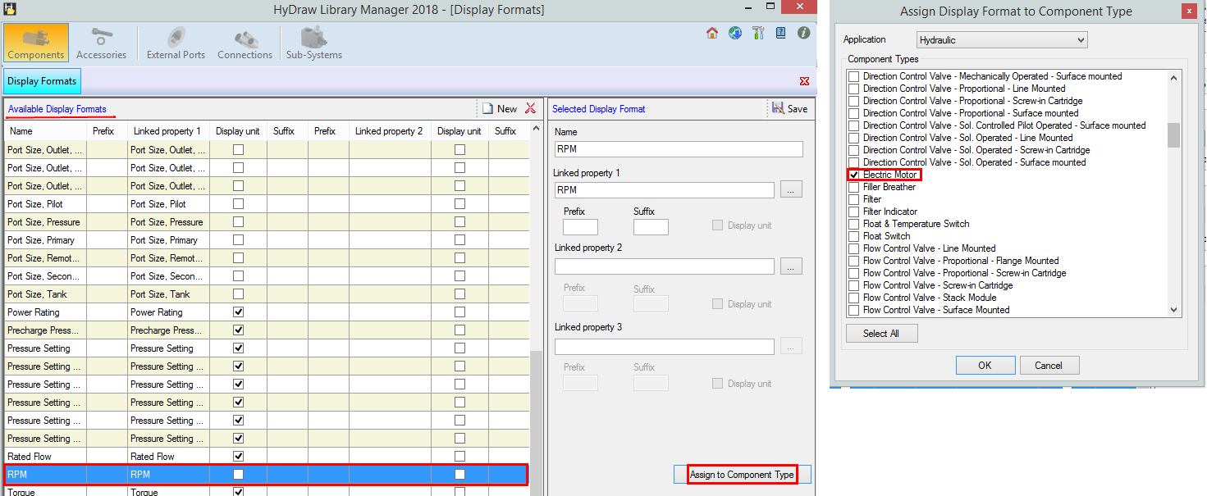

1. Click, **Save**.

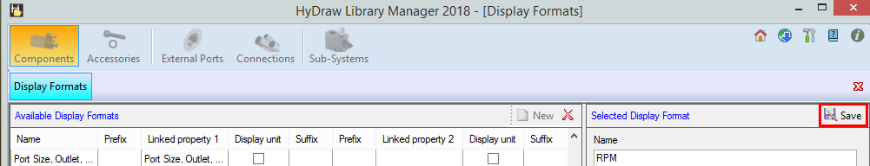

1. Click .

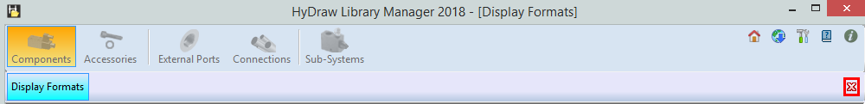

**II. HyDraw CAD: -**

1. In **Circuit** Ribbon, click **Update** menu. 
2. Select All or required symbols in the drawing.
3. From the command line option, select **Components**.

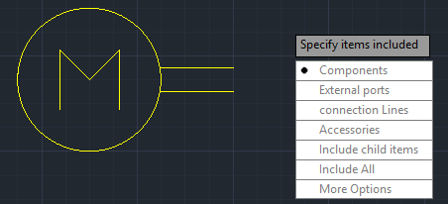

*The Update Properties dialog displays.*

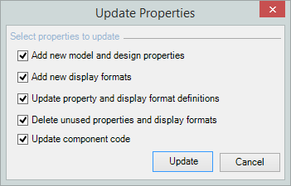

1. Click the **Update** button.
2. The newly added property “RPM” is reflected in Model data and newly added Display Format is reflected in Display settings of the HyDraw Property Manager.

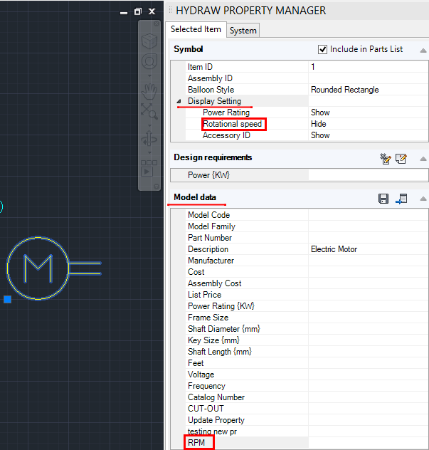

1. Enter value RPM and it is displayed in the drawing.

